Guidelines and Application
Community Child Care Connection
2801 W. Lawrence Ave
1-800-676-2805

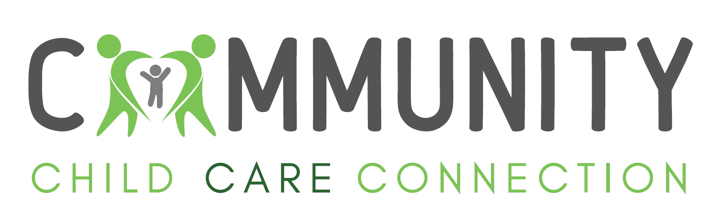

July 1, 2023 –June 30, 2024

In partnership with Community Child Care Connection, the Illinois Department of Human Services’ Division of Early Childhood (IDHS-DEC) is providing funds to assist child care practitioners to achieve First Aid (FA)/Cardiopulmonary Resuscitation (CPR) Certification. Below are the guidelines, please read carefully. For the purpose of this document “program” refers to both child care centers and family child care homes; “provider” is inclusive of all child care practitioners (center staff & family child care).

- Eligibility Criteria:
- Provider must be employed by a program that is actively providing child care at the time of application.
- Program may be licensed or license exempt.
- Provider must be a current member of the Gateways to Opportunity Registry (applies to individual and group).
- The child care program must be listed on the Child Care Resource & Referral (CCR&R) agency’s referral database and must currently be providing care in one of the following Illinois counties or the following Illinois county: Christian, Logan, Mason, Macoupin, Menard, Montgomery, Morgan, Sangamon or Scott.
- The child care program must have no unpaid financial obligation to the CCR&R agency or the IDHS-DEC.
- Priority is given to programs currently caring for 50% or more children whose care is paid for by the IDHS Child Care Assistance Program (CCAP).

- Funds are available for:
- FA/CPR training that occurs between July 1, 2023 – June 1, 2024.
- Individual costs associated with Pediatric FA/CPR (registration fee, student workbook, certification card). For school age providers, FA/CPR should be specific to the age served.
- Center staff on-site FA/CPR that is arranged by a child care program (registration fee, student workbook, certification card).
- Initial or renewal certification.
- FA/ CPR curriculum must be from one of the following approved entities:
American Heart Association American Safety & Health Institute (ASHI)
American Red Cross American Trauma Event Management (ATEM)
Emergency Care and Safety Institute (ECSI) Edward Atkinson/Emergency Response Health Network
Ellis & Associates, Inc.-Orlando, FL EMS Safety Services
Know CPR MEDIC FIRST AID National Safety Council Pacific Medical Training
Pro-Trainings, LLC R.H. Sanders & Associates/Titan CPR Associates

- Funds do not cover:
- Incomplete or failed training/certification.
- Adult only FA/CPR.
- Travel to/from training.
- Out of state training.
- Purchase of CPR manikins, lungs, valves, DVDS, masks, shields, kneeling pads, gloves, or training kits.
- Cost of meals or refreshments.
- Fee for a replacement certification card.
- FA/CPR registration fee for volunteers at a child care program.
- No show and/or penalty fees.

- Application process:
- Submit a completed application along with the required supporting documentation:
Proof of Gateways Registry Membership.
Completed W-9 form.
Proof of enrollment for payment to be made directly to the trainer/entity or
Receipt/proof of payment if requesting reimbursement.
For Center Group Training – an attendance sheet for those attending/completing the course including the Gateways to
Opportunity Registry Membership ID.
- The CCR&R will notify you in writing if your application has been approved or denied.

- Funding Amount/Payment:
- The cost of FA/CPR will be funded at 100% up to $150 per participant.
- Funding is limited and is not guaranteed.
- Payment requests can be made to the FA/CPR trainer or entity.
- Reimbursement can be made to an individual or a child care program.

- Deadline to apply:
- Ongoing as funding allows.
- Final date to submit a request for funding is Friday, June 7, 2024.

- Contact information:
- Lori Verhulst, Training Coordinator
- 217-525-2805 ext. 8325 or LVerhulst@4childcare.org

- Other information:
- Completion of the FA/CPR training must be documented in the Gateways Registry within 30 days of completing the training. This can be done by
  - An individual self-reporting in the Gateways Registry or
  - Submitting documentation to the CCRR for data entry into the Gateways Registry
- Incomplete applications will delay the time to process.

Check list – Is your Application Complete?
- All parts of the application are complete. If a question was not applicable, I inserted NA.
- I signed and dated the application.
- I attached the required supporting documentation
Proof of Gateways Registry Membership
Completed W-9 form
Proof of enrollment or Receipt/proof of payment
For Center Group Training – an attendance sheet for those attending/completing the course including Gateways #
- The payment information I have submitted is correct.
- I understand an incomplete application will delay the review process.
- I have made a copy of the application and all supporting documentation for my records.

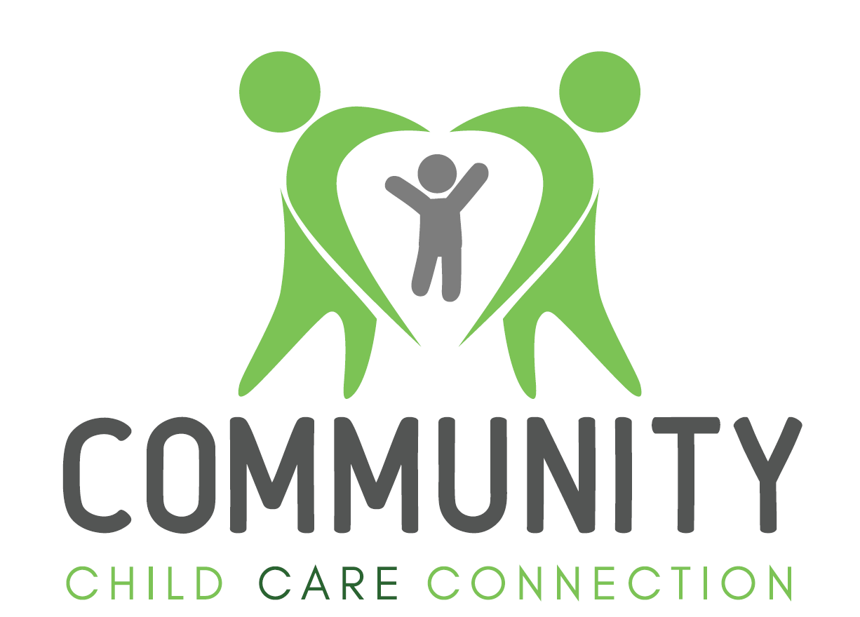

STEP 1: Applicant Information
Requesting funds as: An individual Group Training (child care centers only)
Applicant First Name: | Applicant Last Name:
Applicant Address:
City: State: Zip Code: County:
Mailing address (if different):
Program Phone #: ( ) | Alternate phone #: ( )
Gateways Registry #: | Email: Personal Program
Program is: Licensed Child Care Center License Exempt Child Care Center
Licensed Family Child Care License Exempt Family Child Care
Program (work site) Name:
Program (work site) Address:
City: State: IL Zip Code: County:
Percentage of IDHS CCAP Children: To calculate: Total Number of children with IDHS Financial Assistance DIVIDED by Current total Enrollment MULTIPLIED by 100 EQUALS Percentage of Children Receiving IDHS Assistance. (FCC providers: include your own children, under age 13, in enrollment)
÷ X 100 = %
# of IDHS Children Current Total Enrollment Percentage of IDHS Children
STEP 2: Training Information
Date(s) of Training: | Name of Trainer:
Location of Training: (list address, city, IL, zip, county):
CPR First Aid Combination FA/CPR | Initial Renewal |  | Face to face Hybrid
Length of training: Face to Face______ Hybrid: on line component________ / face to face component ______
Entity (check one)
American Heart Association American Safety & Health Institute (ASHI)
American Red Cross American Trauma Event Management (ATEM)
Emergency Care and Safety Institute (ECSI) Edward Atkinson/Emergency Response Health Network
Ellis & Associates, Inc.-Orlando, FL EMS Safety Services
Know CPR MEDIC FIRST AID National Safety Council Pacific Medical Training
Pro-Trainings, LLC R.H. Sanders & Associates/Titan CPR Associates
Amount Requested |  | Funding Maximum | Actual Cost
Individual FA/CPR Cost per person $ _______ |  | 100% of the actual cost | $
Center Group FA/CPR  Cost per person $_____ x_____ total attendees = Actual cost |  |  | $
TOTAL AMOUNT |  |  | $

STEP 3: Payment Information
Requesting payment be made/mailed to: Individual Child Care Center First Aid/CPR Trainer/Entity
Make check payable to: ___________________________________________________________________________

Mail check to: ___________________________________________________________________________________
Address / City / State / Zip Code
Applicant Social Security # FEIN # ____________________________________ required
STEP 4: Authorization
I have completed all documentation that was requested in the instructions and requirements. I certify that the above information is true and accurate, that I have not been indicated of child abuse and neglect and that my name or the names of my employees (if applicable) are not listed on the child abuse tracking system. Further, I grant permission for a representative of the Illinois Department of Children and Family Services or their agent to release information about my pending or current Day Care Home, Day Care Group Home or Day Care Center license if applicable to my application.

Applicant Printed Name Date Applicant Signature Date

Return a complete application and all required supporting documentation (see #4 + checklist) to:
Community Child Care Connection, Inc.
ATTN: Training Coordinator
2801 W. Lawrence Ave.
Springfield, IL 62704

CCR&R USE ONLY:
Date Received: | Reviewed by: | Complete? Yes No
Approved Date / Amount $
Pending Date/Reason
Communicated with applicant Date / Message
Denied Date / Reason

